ENGLISH FIRST ADDITIONAL LANGUAGE
GRADE 8
LANGUAGE TEST
TERM 1 2013
TOTAL: 40
Time: 1 Hour
Contents
- Comprehension (15)
- Summary (5)
- Language (20)
Instructions
- Write your name, surname and grade at the top.
- Leave a line open between answers.
- Answer each question on a new page.
Comprehension
Why dassies have no tails.
There are many stories in Africa which explains why animals do certain things or why they look the way they do. There are many stories, for example, which tell how clever rabbits and monkeys are. There are stories which explain why hyenas look ugly and why zebras have stripes.
This story explains why dassies have no tails. It is a traditional Zulu story.
It is said that the dassie went without a tail because he sent other animals to get it. For on the day that tails were distributed, the sky had become clouded; other animals then went out to fetch their tails, to the place where they were given away. The dassie didn’t go with them. Instead he asked, “O my neighbours, can you bring back my tail for me? I cannot go out of my hole, because it is raining.” But they paid no attention to him.
So the others returned with tails, but the dassie himself never had a tail because he didn’t feel like going out in the rain. He lost all the advantages of having a tail; for a tail is useful for driving away flies. The dassie has nothing to brush them off with.
Such then is the tale of the dassie. It is understood by those who don’t like to work when the weather is bad; they ask others to bring things for them.
So it is said in answer to a person who says, “O, get me…” You say when you refuse him: “The dassie went without a tail because he asked others to get it for him. So-and-so, do not ask me to fetch for you.” You say this so that when you return without it he may not ask questions like, “How is it that you have not brought it for me, when I asked you to do so?” You answer him with the story about the dassie. So he who asks goes away.
Question 1
  - Why did the dassie not go and fetch his own tale?
(1)
1.2 Which of these words do you think describe the dassie:
A. lazy
B. stupid
C. afraid
D. cold
E. feeling
(1)
1.3 What advantages did the dassie lose?
(1)
1.4 What sort of people will understand this story well?
(1)
1.5 When would it be useful to tell this story?
(1)
1.6 Do you think this story is true about the dassie? Give a reason for your answer.
(2)
1.8 Which word in the passage also means “handed out”? Write down only ONE word
(1)
1.9 From which culture does this story come?
(1)
1.10 In your own words state what lesson is there to be learned from this story.
(3)
1.11 What is meant with the expression “So-and-so”?
(1)
1.12 Name the punctuation marks used in the following extracts:
1.12.1 O get me…
1.12.2 So-and-so
(2)
[15]
Question 2 – Summary
2.1 Read the passage below and find in it five facts about the Himba hairstyles. List your facts 1-5. Use exactly 50 words. Write down how many words you have used in brackets at the end of your summary. (5)

BRILLIANT HAIR
Namibian hairstyles show that there are many different peoples in the country. But they also show the huge gap in living conditions between the rich and the poor. By looking at a person’s hairstyle in earlier times, one could see what community the person belonged to. Today, too, sometimes the hairstyle shows if the person who wears it is a child, a teenager or is married.
This custom is still alive among the Himba people, who live as nomads in Kaokaland in then north-west of Namibia.
Himba boys wear a short, single plait when they are old enough to herd goats and cattle. Later on they wear two thick plaits and when a young man gets married his hairstyle is changed to a turban-type head-dress.
Young Himba girls wear two plaits which hang over their faces until they are about 12 years old. Then the plaits are changed into long thin strands which fall loosely around the head. Thickness and length of hair are considered a sign of beauty. So the Himba girls and women add extra hair and fibre to their own hair.
SECTION C – LANGUAGE
QUESTION 3
CARTOON
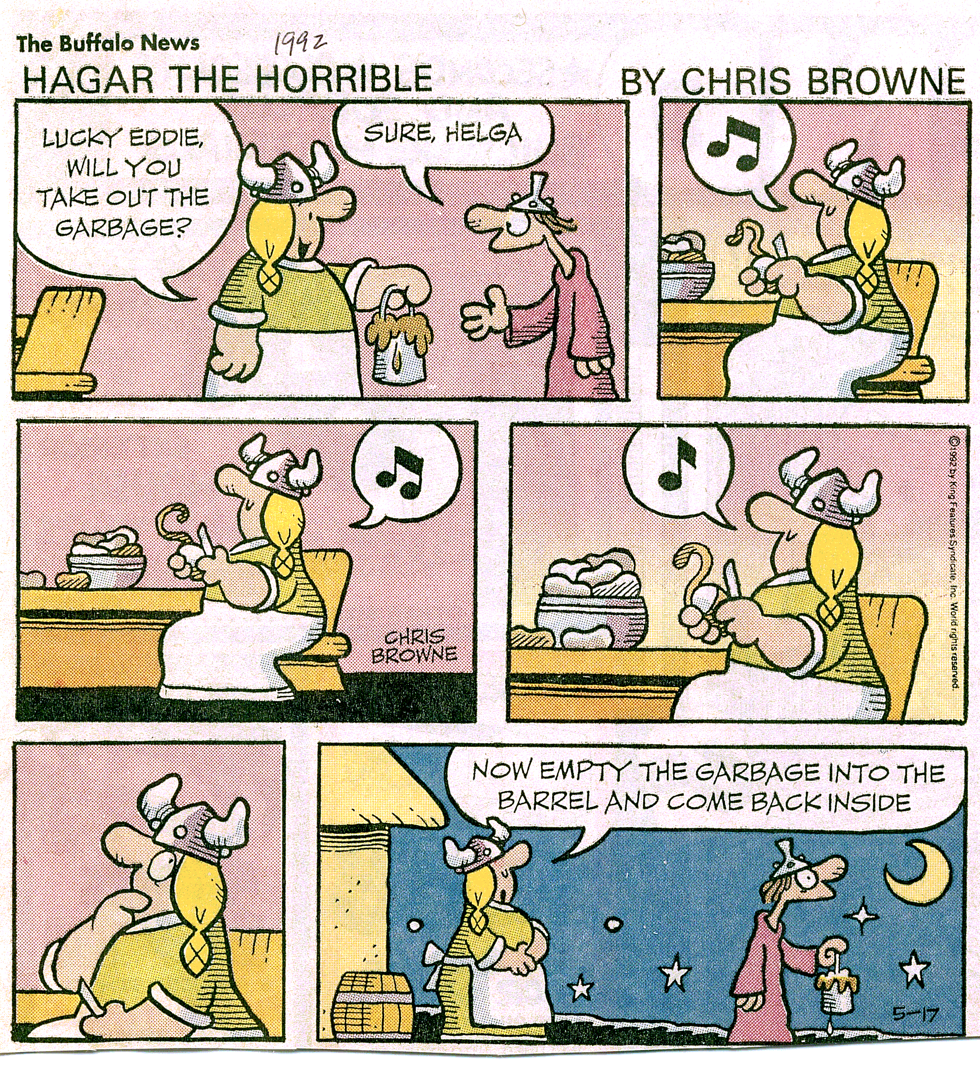
  - What instruction does Helga give Eddie? Begin your answer with:
Helga asks Eddie if …
(2)
  - What does the musical note in the bubbles refer to?
(1)
3.3 How do you know it is night time and not day time?
(1)
3.4 Why is Lucky Eddie still outside with the garbage in his hand?
(1)
QUESTION 4
ADVERTISEMENT
QUESTION 5

4.1 Who will probably be customers at this shop?
(1)
4.2 What does this shop sell?
(1)
4.3 What is the name of the shop?
(1)
4.4 How much will it cost you to look like a million bucks?
(1)
4.5 What is the meaning of the expression “you will look like a million bucks”?
(1)
[5]

EDITING
Question 5
MINE TRAGEDY
105 crushed in fall down shaft
ORKNEY – A man-cage, with 105 miners in it, fell to the bottom of Vaal Reefs gold mine on Wednesday.
The cage fell to the bottom of the mine’s number 2 shaft when it was hit from above by a locomotive and carriage. The cable of the cage was hit and broken by the locomotive and the cage fell 500 meters. Number 2 mine shaft is 2 300 metres below the surface of the earth.
The president of the National Union of Mineworkers said he had been down to the area where 50 rescue workers were trying to reach the victims. He said, “There were 50 miners on each level of the man-cage and no survivors are likely.”
A disaster fund is to be established to help the families of the miners.
5.1 Write down an example of a proper noun from the passage. Just write one word.
(1)
5.2 Write down an example of a common noun from the passage. Just write one word.
(1)
5.3 Write down an example of an abstract noun from the passage. Just write one word.
(1)
5.4 Write down an example of a collective noun from the passage. Just write one word.
(1)
5.5 Change the following sentence from the passage into a question tag:
Number 2 mine shaft is 2 300 metres below the surface of the earth.
(3)
5.6 Name the two punctuation marks used below:
ORKNEY – A man-cage
(2)
5.7 Write out the number 50.
(1)
[10]

